6 November 2022

Video here

Behind every good agricultural show, wherever it is in New Zealand, are hundreds of volunteers who are the heartbeat of such events.

At the New Zealand Agricultural Show in Christchurch, the country’s biggest rural show of its kind, volunteers who’ve clocked up decades either competing, or volunteering, are hard at work preparing for November 9-11.

It’s particularly poignant following a two-year hiatus because of Covid and financial woes that have seen new management ushered in and a $1 million loan from the Christchurch City Council.

Nicky Hutchinson and Richard Lemon, both past presidents of the Canterbury Agricultural and Pastoral Association (CAPA), are among the many who have been hard at work for months.

Based on the family dairy farm in Ashburton, Richard’s first experience of The Show was as a five-year-old coming to town with his parents. As a teenager he slept in the cattle barn during The Show with mates. His family competed in the sheep and horse arenas. By 2012, he was president during the 150th celebrations, attended by the then Prince Charles and Camilla Parker Bowles.

Today, nearly 70 years on from that first outing, Richard is still heavily involved, driving to Canterbury Agricultural Park three times a week to lend a helping hand.

“It’s all about the satisfaction of being able to assist. The biggest kick I get is watching people’s faces and seeing how happy the kids are when they’re up close to the animals or see a lamb being born.

“In that way, the essence of The Show hasn’t changed.”

Nicky has been involved with all things equestrian, competing in and later organising the multitude of events for nearly 60 years. This year she’s once again overseeing all things equestrian and when not occupied with that, Nicky is helping to polish the silverware in the form of 276 trophies and cups.

Nicky was the first female president of CAPA, appointed in 2015, and all up has spent nearly 60 years involved with The Show in one form or another.
Her motivation is little changed from when she first visited The Show in 1962 when her parents, high country farmers, travelled from Double Hill Station in Rakaia, to the showgrounds.
“It’s always been about having fun. Having been a farmer all my life, I love the livestock and seeing the improvements in breeding. The other special thing is seeing all the young children, especially kids from the city, seeing the animals up close and where their butter and milk come from.”
The association’s general manager, Tracy Ahern, says The Show is not possible without volunteers like Richard, Nicky and the accumulated wisdom and experience of many others volunteers.
She also pays tribute to a group she calls The Show Saviours, people who made substantial donations over the past two years to keep the event going – albeit in a much reduced form – during Covid.
“We’re so excited about bringing The Show back to Christchurch this year. It’s just extraordinary watching everyone come together to produce what we hope will be THE BEST SHOW EVER.
“A particular focus this year is youth – a lot of children don’t get to experience country life and get up close to farm animals so we’re thrilled about being able to offer free entry for kids.”
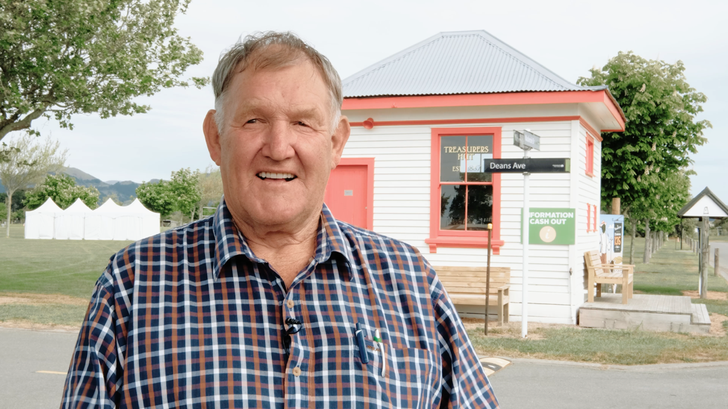
(Play video below by clicking on it)

For further information,
Tracy Ahern, General Manager, GM@theshow.co.nz, 027 5444 557

